You are given an integer array nums with no duplicates. A **maximum binary tree** can be built recursively from nums using the following algorithm:

1. Create a root node whose value is the maximum value in nums.
2. Recursively build the left subtree on the **subarray prefix** to the **left** of the maximum value.
3. Recursively build the right subtree on the **subarray suffix** to the **right** of the maximum value.

Return *the****maximum binary tree****built from*nums.

**Example 1:**

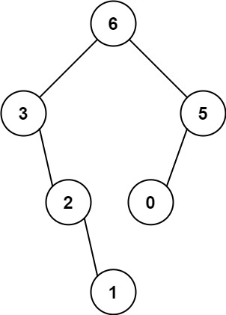

**Input:** nums = [3,2,1,6,0,5]

**Output:** [6,3,5,null,2,0,null,null,1]

**Explanation:** The recursive calls are as follow:

- The largest value in [3,2,1,6,0,5] is 6. Left prefix is [3,2,1] and right suffix is [0,5].

- The largest value in [3,2,1] is 3. Left prefix is [] and right suffix is [2,1].

- Empty array, so no child.

- The largest value in [2,1] is 2. Left prefix is [] and right suffix is [1].

- Empty array, so no child.

- Only one element, so child is a node with value 1.

- The largest value in [0,5] is 5. Left prefix is [0] and right suffix is [].

- Only one element, so child is a node with value 0.

- Empty array, so no child.

**Example 2:**

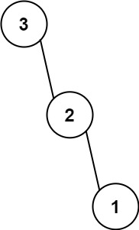

**Input:** nums = [3,2,1]

**Output:** [3,null,2,null,1]

**Constraints:**

* 1 <= nums.length <= 1000
* 0 <= nums[i] <= 1000
* All integers in nums are **unique**.